- A software development team is tasked with building an online food delivery platform that allows customers to order food from local restaurants, track their orders in real-time, and make payments online. The platform should also support restaurant owners in managing menus, orders, and delivery schedules, while providing delivery personnel with tools to accept and complete delivery requests.
  - Who are the key actors and stakeholders involved in this system? Provide a list and briefly describe their roles and interests.
  - Create two scenarios, one for a customer placing an order and another for a restaurant owner updating their menu. Based on these scenarios, draft initial use cases for each scenario.
  - Draw a use case diagram that illustrates the relationships between the actors (e.g., customer, restaurant owner, delivery personnel) and the use cases (e.g., place order, update menu, track delivery). Explain how these relationships ensure the system meets the needs of all stakeholders.

1. Key Actors and Stakeholders
Actor/Stakeholder | Role and Interest
Customer | Browses food, places orders, pays and tracks delivery.
Restaurant Owner | Manages menu, prices, availability and orders.
Delivery Personnel | Accepts delivery requests and updates delivery status.
Payment Gateway | Processes and authorizes online payments.
Platform Owner | Manages business operations, revenue and customer satisfaction.
Project Manager | Manages project scope, cost, schedule and quality.

2. Scenario 1: Customer Places an Order
- Customer logs into the system.
- Selects a restaurant and food items.
- Adds items to the cart.
- Enters delivery address.
- Selects online payment.
- Payment Gateway processes payment.
- System confirms the order.
- Customer tracks the delivery.

Initial Use Case: Place Order
- Actor: Customer
- Goal: Order food for delivery.
- Precondition: Customer is logged in and food is available.
- Main Flow: Select food → Add to cart → Checkout → Payment → Order confirmation.
- Postcondition: Order is confirmed and sent to the restaurant.

3. Scenario 2: Restaurant Owner Updates Menu
- Restaurant Owner logs into the system.
- Opens Menu Management.
- Selects a food item.
- Changes price/availability.
- Saves the changes.
- System updates the menu for customers.

Initial Use Case: Update Menu
- Actor: Restaurant Owner
- Goal: Update food price and availability.
- Precondition: Owner is authenticated.
- Main Flow: Login → Menu Management → Edit Item → Save.
- Postcondition: Updated menu is visible to customers.

4. Use Case Diagram
ONLINE FOOD DELIVERY SYSTEM
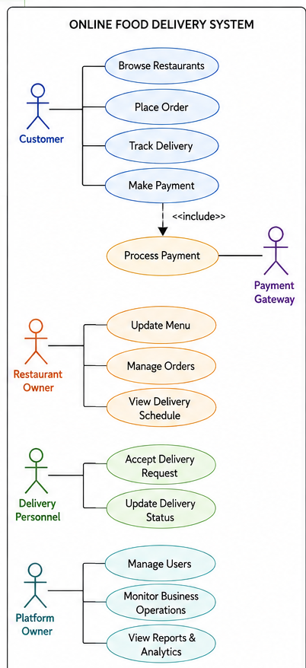

5. Relationships and Stakeholder Needs
- Customer → Place Order: Supports convenient food ordering.
- Customer → Track Delivery: Provides delivery visibility.
- Restaurant Owner → Update Menu: Maintains accurate price and availability.
- Restaurant Owner → Manage Orders: Supports efficient restaurant operations.
- Delivery Personnel → Update Delivery Status: Enables real-time tracking.
- Payment Gateway → Process Payment: Provides secure online transactions.
- Place Order <<include>> Make Payment: Ensures payment is completed as part of the ordering process.

Conclusion
The use cases connect actors with required system functions, ensuring customer convenience, restaurant efficiency, delivery coordination and secure payment processing.

Memorization Technique
Actors = “C-R-D-P”
C → Customer
R → Restaurant Owner
D → Delivery Personnel
P → Payment Gateway
Main Use Cases = “B-P-T-M-U”
B → Browse
P → Place Order / Payment
T → Track Delivery
M → Manage Orders/Menu
U → Update Delivery Status
Easy flow:
Customer Orders → Payment → Restaurant Prepares → Delivery → Customer Tracks

- A software development team is tasked with building an online food delivery system. Develop use cases for each scenario for all stakeholders.

Use Cases for Online Food Delivery System

1. Customer
Use Case: Place Order
- Actor: Customer
- Goal: Order food online.
- Precondition: Customer is logged in and food is available.
- Steps:
  - Select restaurant and food.
  - Add food to cart.
  - Confirm delivery address.
  - Make payment.
  - System confirms order.
  - Restaurant receives order.
- Postcondition: Order is successfully placed.
Use Case: Track Delivery
- Actor: Customer
- Steps:
  - Open active order.
  - View order status.
  - View delivery progress/location.
- Postcondition: Customer knows delivery status.

2. Restaurant Owner
Use Case: Manage Menu
- Actor: Restaurant Owner
- Goal: Maintain restaurant menu.
- Steps:
  - Login to restaurant dashboard.
  - Add/update/delete food items.
  - Change price and availability.
  - Save changes.
- Postcondition: Updated menu is available to customers.
Use Case: Process Order
- Actor: Restaurant Owner
- Steps:
  - Receive new order.
  - Accept/reject order.
  - Prepare food.
  - Mark order as ready.
- Postcondition: Order is ready for delivery.

3. Delivery Personnel
Use Case: Manage Delivery
- Actor: Delivery Personnel
- Goal: Complete assigned delivery.
- Steps:
  - View delivery request.
  - Accept delivery.
  - Pick up food.
  - Update status.
  - Deliver food.
  - Mark as delivered.
- Postcondition: Delivery is completed and recorded.

4. System Administrator
Use Case: Manage Users
- Actor: Administrator
- Steps:
  - View user accounts.
  - Approve restaurant accounts.
  - Update user permissions.
  - Suspend/remove invalid accounts.
- Postcondition: User accounts are properly controlled.

5. Payment Gateway
Use Case: Process Payment
- Actor: Payment Gateway
- Steps: Receive payment request → Authenticate/authorize → Return success/failure.
- Postcondition: Payment status is recorded.

Use Case Relationships
- 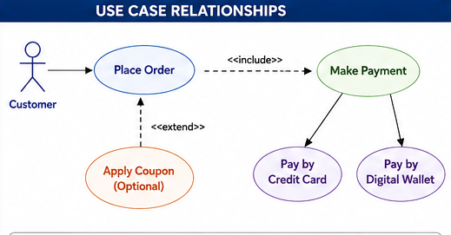

Easy Memorization
Actors: C-R-D-A-P
- C → Customer
- R → Restaurant
- D → Delivery
- A → Admin
- P → Payment
Flow:
Customer Orders → Restaurant Prepares → Delivery Delivers → Customer Tracks → Payment Completes

- Why is stakeholder involvement critical during the requirements gathering phase of a software project, and what are some common challenges faced in ensuring effective participation from all stakeholders? How can these challenges be addressed to ensure accurate and comprehensive requirements?(5)

Stakeholder Involvement in Requirements Gathering
Stakeholder involvement is critical because stakeholders provide the business needs, user expectations and domain knowledge required to develop the correct software.

Importance
- Accurate Requirements – Identifies actual user and business needs.
- Complete Requirements – Reduces missing or overlooked requirements.
- Early Risk Identification – Detects problems before development.
- Conflict Resolution – Helps resolve different stakeholder priorities.
- Customer Satisfaction – Creates ownership and acceptance of the system.
- Better Design – Provides a strong foundation for design, development and testing.

Common Challenges
- Communication Barriers – Technical language and misunderstandings.
- Unclear Requirements – Stakeholders may not clearly know what they need.
- Conflicting Requirements – Different stakeholders have different priorities.
- Changing Requirements – Business needs may change during development.
- Limited Availability – Stakeholders may be busy or unwilling to participate.
- Resistance to Change – Users may fear or reject the new system.

Solutions
- Interviews and Workshops – Directly collect stakeholder needs.
- Prototyping – Show an early version to clarify unclear requirements.
- Agile Development – Obtain continuous stakeholder feedback.
- Prioritization and Negotiation – Resolve conflicts based on value, cost and risk.
- Use Cases and Scenarios – Represent requirements clearly from the user's perspective.
- RTM – Trace requirements from source → implementation → testing.
- Reviews and Validation – Check requirements for correctness, completeness and consistency.

Example: Room Rent Booking System
For a room rent booking system, stakeholders include tenant, landlord and administrator.
- Tenant → wants room search and booking.
- Landlord → wants room and rent management.
- Admin → wants user and system management.
If landlords want monthly rent while tenants want daily booking, stakeholder discussion and negotiation are required to define the correct requirement.

Conclusion
Stakeholder involvement → Accurate requirements → Better software → Higher customer satisfaction

Memorization Technique
Remember “A-R-C-C-S”
A → Accurate requirements
R → Risk reduction
C → Complete requirements
C → Conflict resolution
S → Satisfaction
Challenges: “U-C-C-C-R”
U → Unclear
C → Communication
C → Conflicts
C → Changes
R → Resistance

- Why is stakeholder involvement crucial in requirements elicitation? Explain the challenges faced during the requirements gathering process and how they can impact the success of a software project.

